|  |  |  |
| --- | --- | --- |
| Courier Management System |  |  |
| DATE  STARTING 27-05-2024  SUBMITING 26-06-2024 | Faculty  Sir Wali Muhammad | batch  2307E1 |
|  |  |  |

| SERIAL NO. | enrollment | STUDENT nAME |
| --- | --- | --- |

|  |  |  |
| --- | --- | --- |
| 1. | Student1496139 | Ismail Nooruddin |
| 2. | Student1496338 | Zohaib Khan |
| 3. | Student1496980 | Muhammad Shani Qureshi |
| 4. | Student1496348 | Muhammad Ahmed |
| 5. | Student1496138 | Abdullah Fareed |

***Dashboard php***

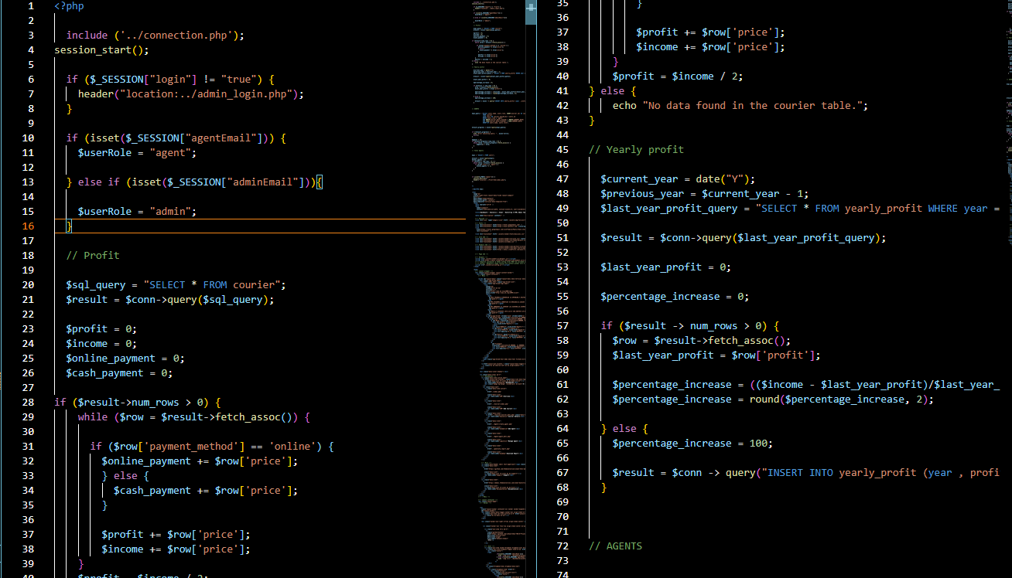

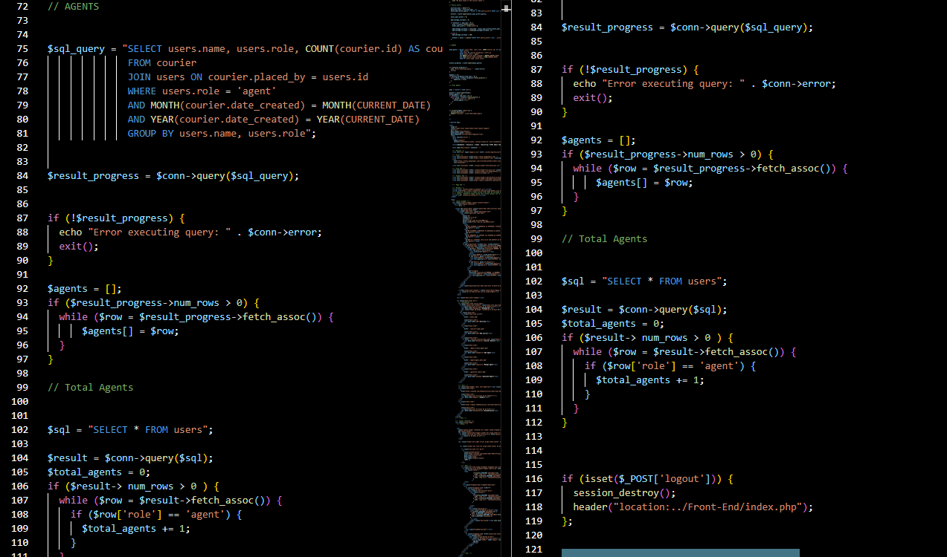

***Add courier***

 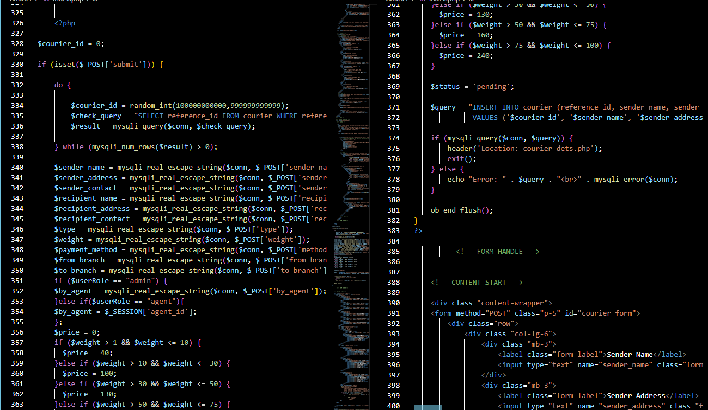

***Reset password otp***

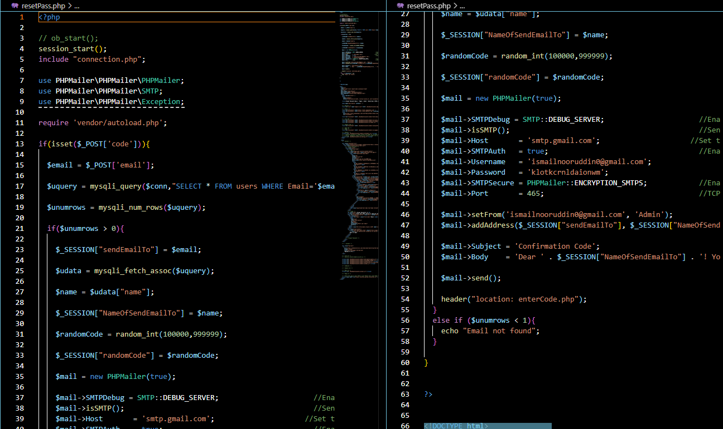

***Login***

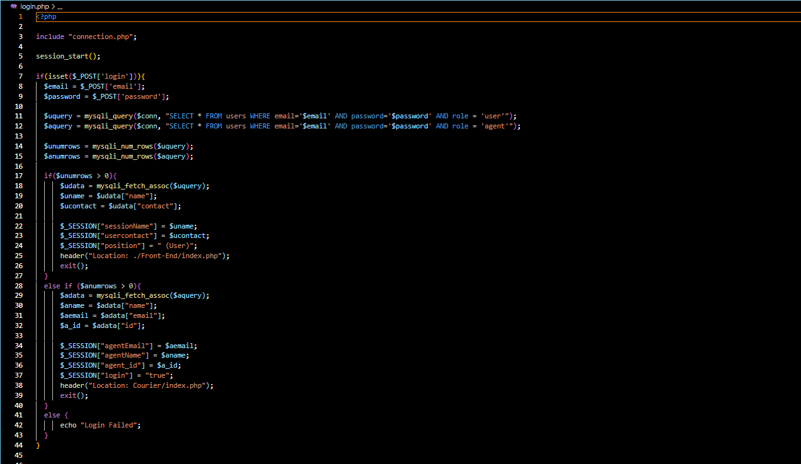

***Thank You for Reading the Documentation.***

***Please Follow the Instructions Above!!***